Technical Architecture – AutoSage App Using Gemini Flash
AutoSage is an AI-powered vehicle expert application built using Streamlit and Python. The system integrates Gemini 2.5 Flash API to provide intelligent vehicle recommendations, comparisons, and maintenance guidance. The architecture consists of a user interface layer, application logic layer, external AI services, and database storage components.

Architecture Diagram

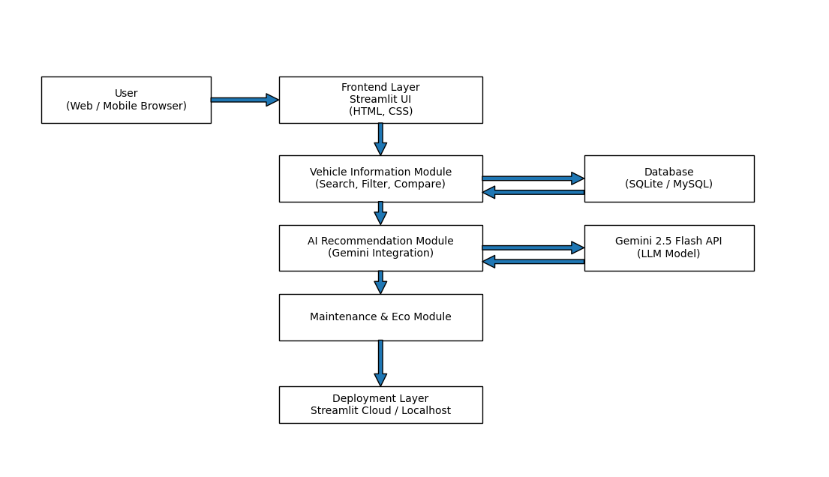
S.No | Source Component | Connected To | Purpose of Connection | Technology Used
1 | User (Browser) | Streamlit UI | User enters vehicle queries and interactions | Web Browser
2 | Streamlit UI | Backend Application Logic | Sends user input for processing | Python
3 | Backend – Vehicle Module | Database | Fetch vehicle specifications & pricing | SQLite / MySQL
4 | Backend – AI Module | Gemini 2.5 Flash API | Generate AI-based recommendations | Gemini API
5 | Backend – Maintenance Module | Database | Retrieve maintenance & vehicle data | SQLite / MySQL
6 | Backend Application Logic | Streamlit UI | Send processed results back to UI | Python
7 | Application | Cloud Infrastructure | Deployment & scalability | Streamlit Cloud

